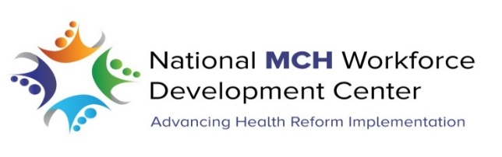

The National MCH Workforce Development Center increases the capacity of the Title V workforce to lead and implement health reform through training, collaborative learning, coaching and consultation in four key areas: systems integration, quality improvement, change management and access to care.

The Center is committed to increasing the workforce capacity of family leaders as part of the MCH workforce it is charged with serving. To this aim, the Center established the Family Engagement Team to develop and disseminate resources for family leaders that will increase their knowledge related to health reform, improve leadership skills and prepare them to build the capacity of a broad and diverse community of family leaders.

The Family Engagement team has the following three major activities underway:

- Action Learning Sets
Action learning uses peer coaching to meet individual leadership challenges as well as develop reflective questioning skills. This program kicked off at the Association of Maternal & Child Health Programs (AMCHP) conference in January 2015 with group assignments, introductions and a practice session. Approximately 20 family leaders are currently participating in four groups. The goals are to:
- Provide education and support for family leaders about health reform implementation
- Use peer coaching to enhance family leader capacity

- The System Support Map
This tool, created by the Center’s Systems Integration Core, is designed specifically for families of children and youth with special health care needs to map their interactions with multiple provider systems in an online, customizable format that is user-friendly and easy to modify as needs change. The process of creating the map enables families to demonstrate, document and troubleshoot the complex web of responsibilities, needs, resources and services involved in supporting a family member with special needs. It further allows them to plan for the future, create wish lists and is a living document that adapts to meet a family’s needs over time.

- Resource Development and Dissemination
In partnership with the Association of Maternal & Child Health Programs the Family Engagement Team is modifying existing Center resources for family leaders’ use in the four key areas that support health reform implementation.

